Tail Recursion:
The recursive call is the last operation in the function, with no pending operations after it returns.
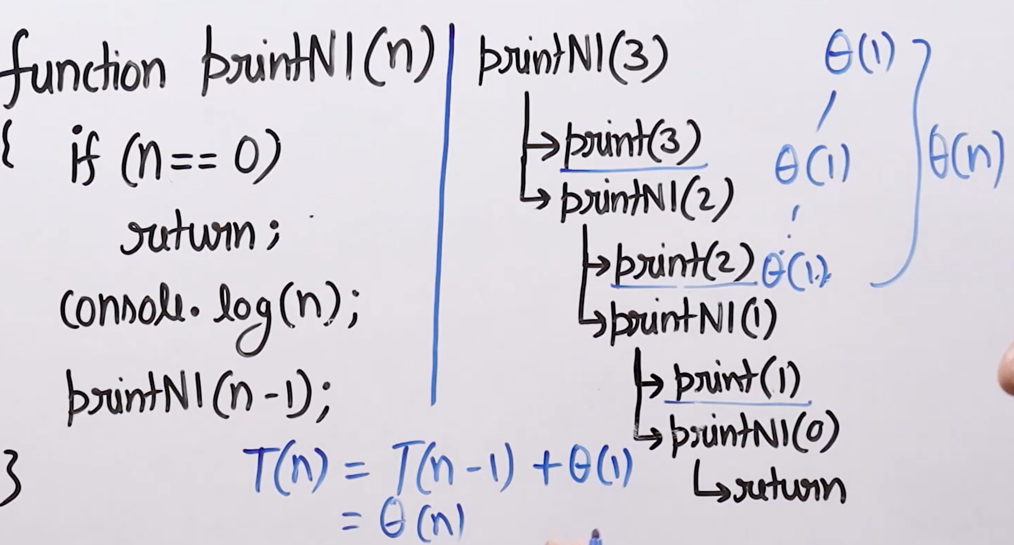
Not Tail Recursion:
The recursive call is not the last operation in the function. After the recursive call returns, there is still more work to be done.
- Requires maintaining a call stack to remember return addresses and local variables
- More memory intensive due to stack usage

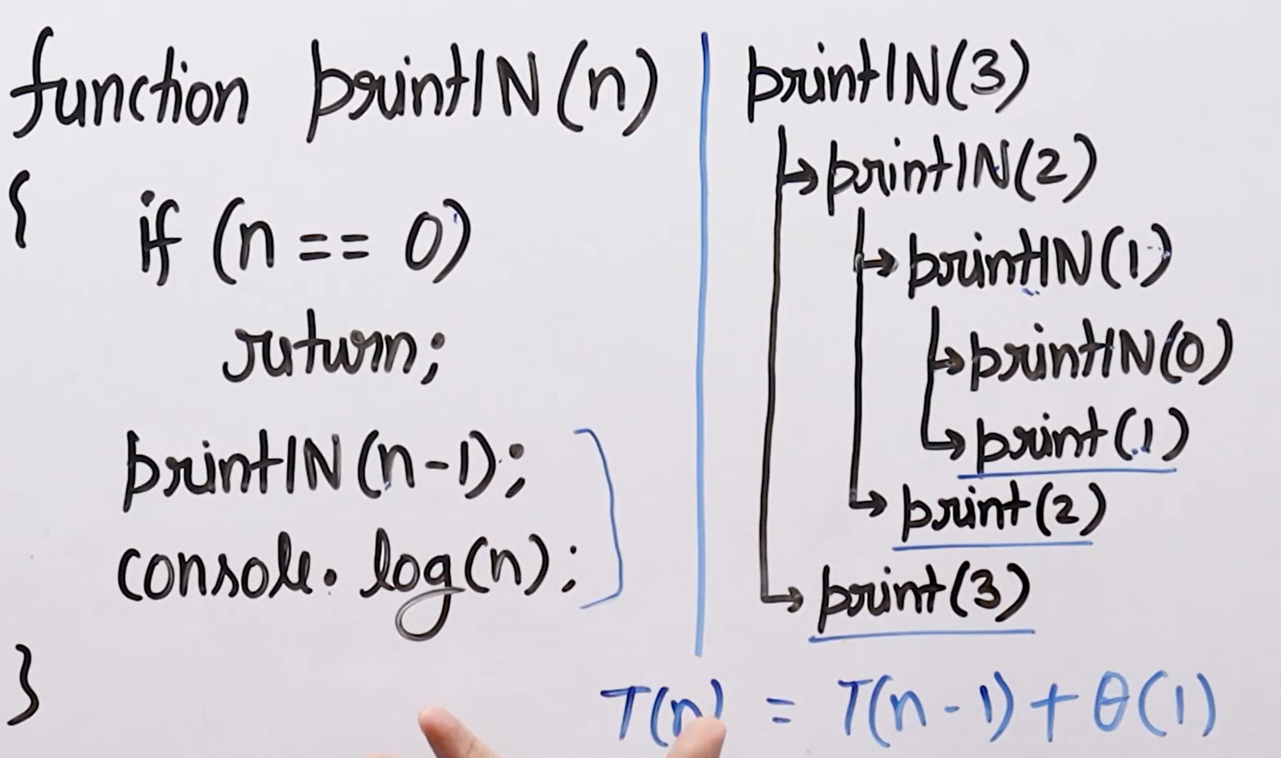

Converting the non-tail recursive function to tail recursive function

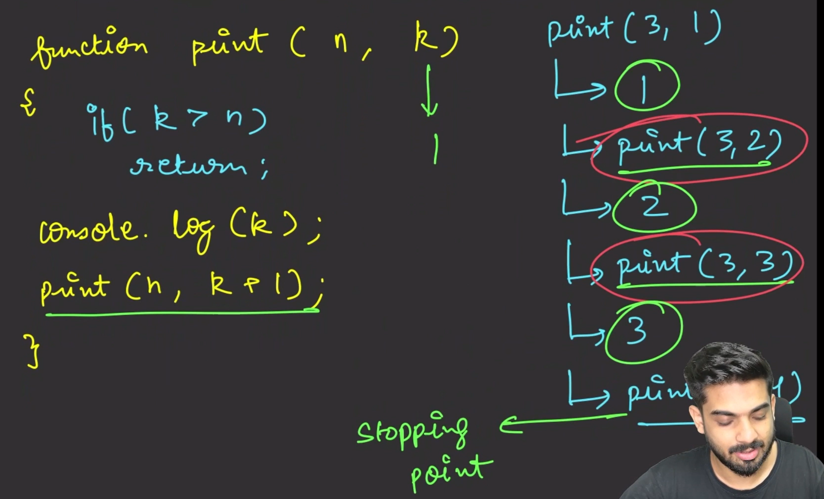
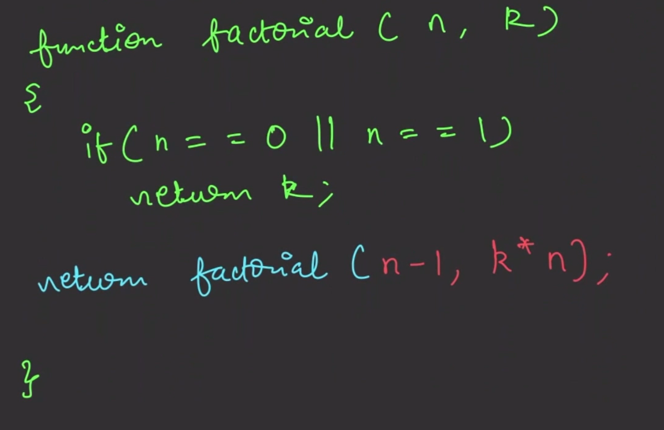
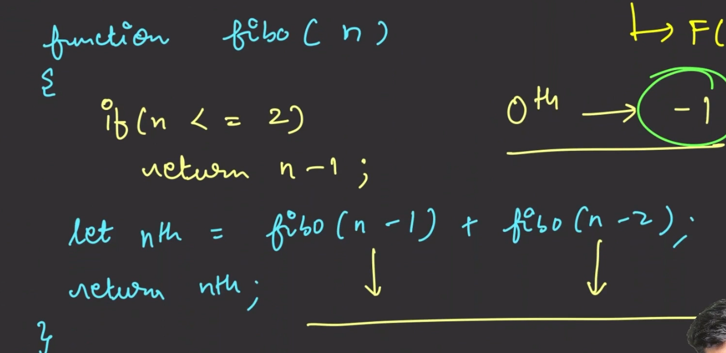
Decreasing Recurssion:
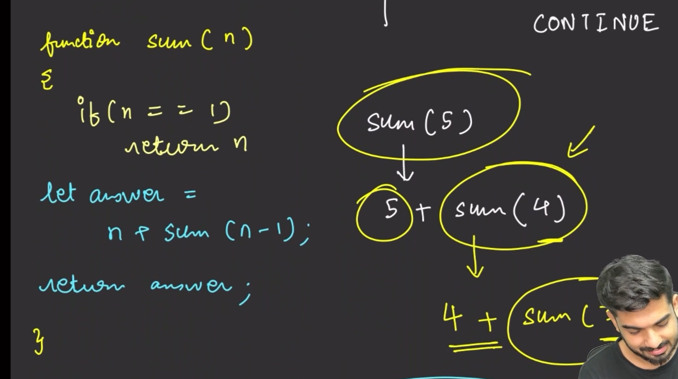
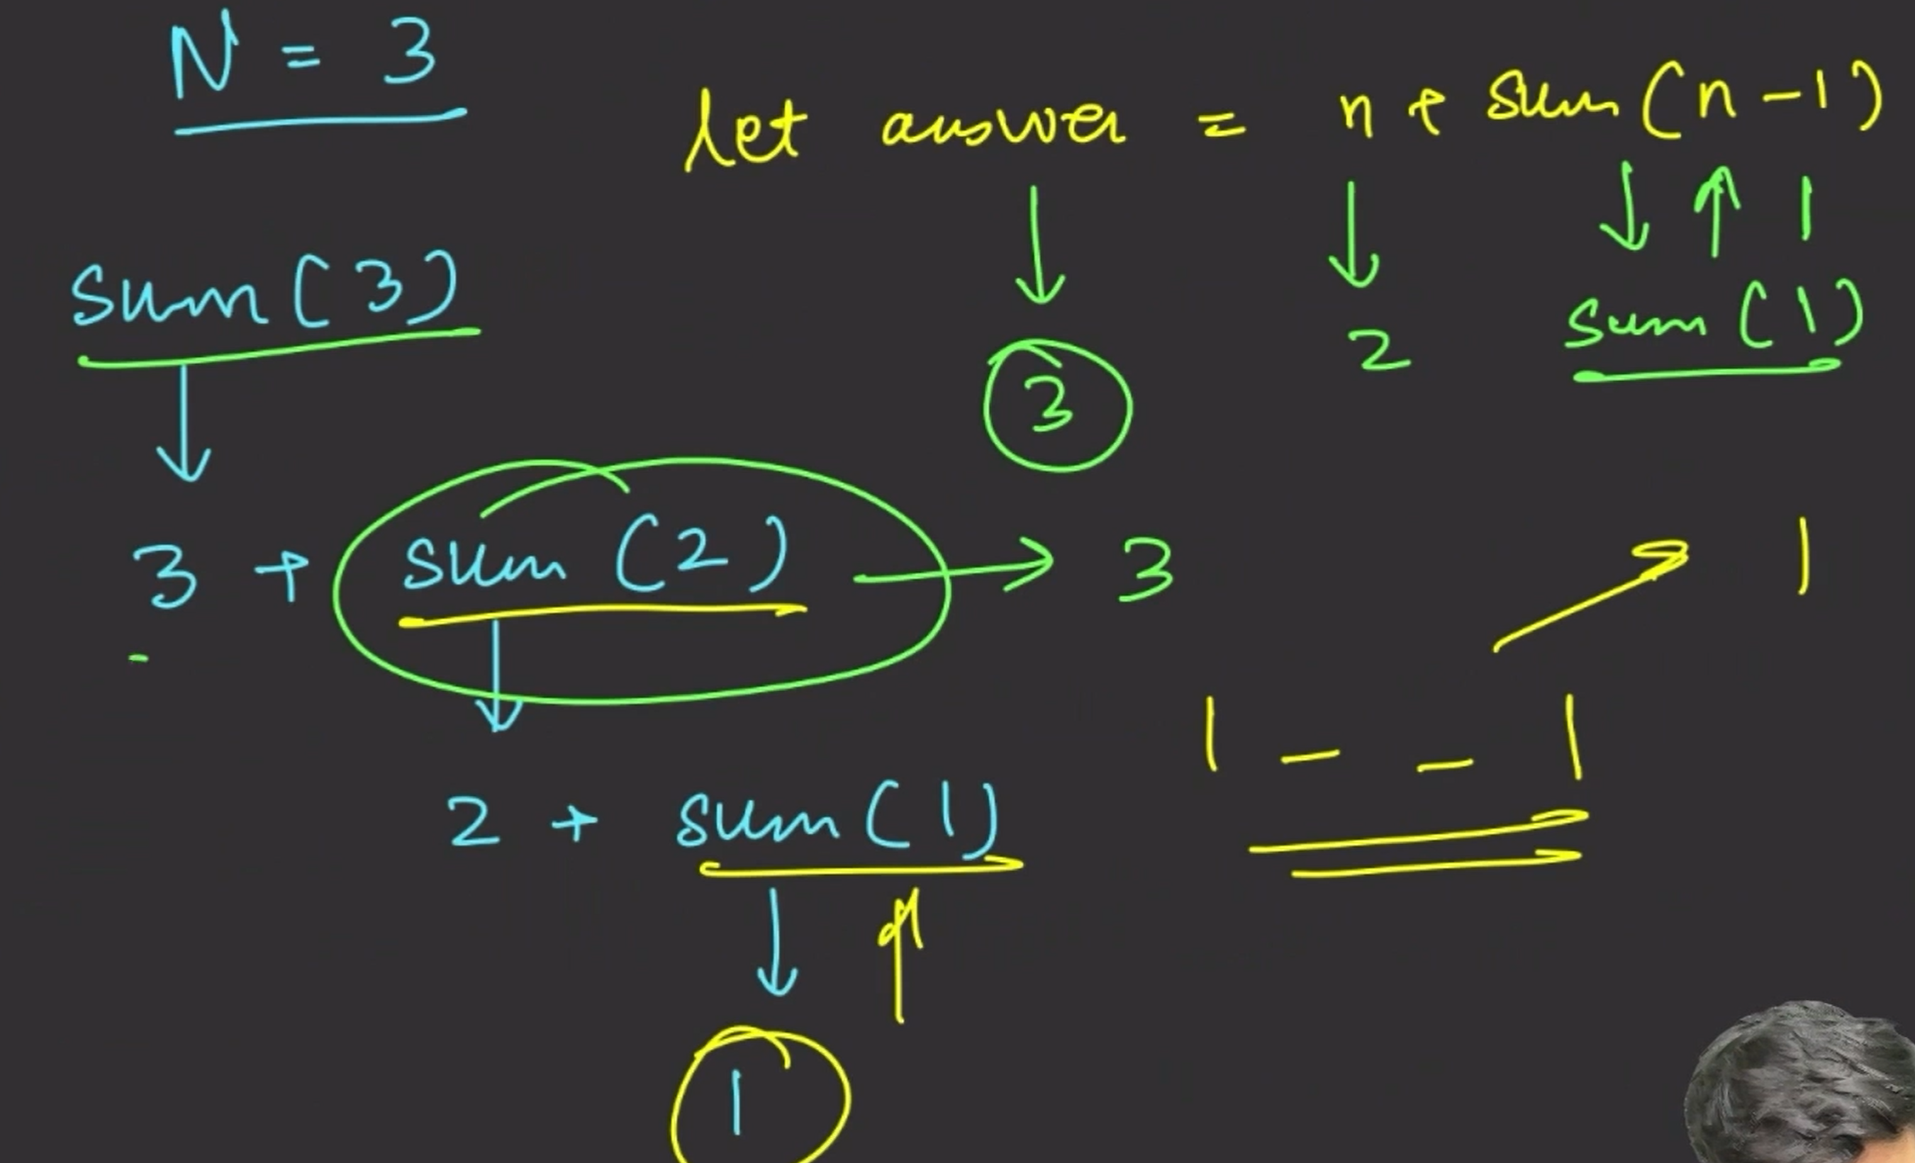
Increasing Recursion:


